**Group Project Milestone 4**

**High Level Design**

MIS 6308 Systems Analysis and Project Management

**PanVac**

(All-in-one Covid-19 vaccination portal for the City of Dallas)

Group 1:

Meenal Badki - MHB180001

Debshila Bhattacharya- DXB200002

Mariya Khalid -MXK153530

Sreejaya Parameswaran - SXP190110

Lakshit Rajput- LXR190004

Prabhavi Soni - PXS190071

Contents

Software Design 3

1. Method Name:userLogin() 3
2. Method Name: registration() 4
3. Method Name: addVaccine() 5
4. Method Name:addMedTechnician() 6
5. Method Name: addRequestforDoses() 7
6. Method Name: viewAppointmentsforDate() 8

Testing 9

Test Strategy

Test case 1: Register 10

Test Case 2: Login 18

Test Case 3: AllocationtoCounter 20

Test Case 4 : Performance 24

User Interface Design 26

Navigation Diagram 26

Windows Navigation 27

1. Registration 27
2. Login28

Meeting Minutes 29

April 18, 2021 29

April 24, 2021 29

April 28, 2021 30

# **Software Design**

|  |  |
| --- | --- |
| **Method Name:** userLogin | **Class Name:** Login |
| **Description of responsibilities:**  Implement the necessary behavior to authenticate users by verifying the login username and password of the users. | |
| **Arguments Received:**    username  password | **Data Type:**    String  String |
| **Return Value:**  loginOutput | **Data Type:**    Boolean |
| **Message and Example:**  Login(username, password) : Boolean  loginOutput = userLogin(“Jeff Bezos”, “Abc1234!” ) | |
| **Algorithm Specification:**    --verify if username and password input are valid  If (username is String value and not null and not spaces ) And ( password is String value and not null and not spaces)  Retrieve username and password from database  --Check for valid username  If valid username  --Check for valid password  If valid Password  Return True  Else  Return False  End If  Else  Return False  End If  Else  Return False  End If | |

|  |  |  |
| --- | --- | --- |
| **Method Name:** registration | **Class Name:** Resident | |
| **Description of responsibilities:**    Implement the necessary behavior to register a Texas resident for vaccination from the available sites, dates, and time slots. | | |
| **Arguments Received:**  firstname  lastname  dob  gender  phoneno  emailaddress  address  city  zipcode  site  date  time | | **Data Type:**  String  String  date  integer  integer  string  string  string  integer  integer  date  date |
| **Return Value:**  registrationResult | | **Data Type:**  Boolean |
| **Message and Example:**  registration(firstname, lastname, dob, gender, phoneno, emailaddress, address, city, zipcode, site, date, time) : Boolean  registrationResult= registration (“Lyla”, “Philip”, 7/11/1990, 1, 4691234567, “Lyla.Philip@abc.com”, “1100 Sutherlands Westheimer Rd”, “Houston”, 75099, 12, 5/1/2021,13:30) | | |
| **Algorithm Specification:**  If (firstname, lastname, dob, gender, phoneno, emailaddress, address, city, zipcode, site, date, time) are not null or spaces then  --Add the registration details to the Resident and Registration tables  Insert the registration details into the database  Return true  Else  Return false  End If | | |

|  |  |  |
| --- | --- | --- |
| **Method Name:** addVaccine | **Class Name:** Vaccine | |
| **Description of responsibilities:**    Implement the necessary behavior to add vaccine details in the system. | | |
| **Arguments Received:**  productname  expirydate  manufaturenumber | | **Data Type:**  String  date  string |
| **Return Value:**  addvaccineResult | | **Data Type:**  Boolean |
| **Message and Example:**  addVaccine (productname, expirydate, manufaturenumber) : Boolean  addvaccineResult= addVaccine (“Pfizer”, 6/2021, “EN9999”) | | |
| **Algorithm Specification:**  If (productname, expirydate, manufaturenumber) are not null or spaces then  --Add the vaccine details to the Vaccine tables  Insert the vaccine details into the database  Return true  Else  Return false  End If | | |

|  |  |  |
| --- | --- | --- |
| **Method Name:** addMedTechnician | **Class Name:** MedTechnician | |
| **Description of responsibilities:**    Implement the necessary behavior to add MedTechnician details in the system. | | |
| **Arguments Received:**  firstname  lastname  dob  gender  licencenumber  phoneno  emailaddress  address  city  zipcode | | **Data Type:**  String  string  date  integer  string  integer  string  string  string  integer |
| **Return Value:**  addvaccineResult | | **Data Type:**  Boolean |
| **Message and Example:**  addMedTechnician (firstname, lastname, dob, gender, licencenumber, phoneno, emailaddress, address, city, zipcode) : Boolean  addMedTechnician Result= addMedTechnician (“Joe”, “Mathews”, 7/11/1985, 1, “AA 12345”, 4691234567, “Joe.Mathews@abc.com”, “1100 Sutherlands Westheimer Rd”, “Houston”, 75099) | | |
| **Algorithm Specification:**  If (firstname, lastname, dob, gender, licencenumber, phoneno, emailaddress, address, city, zipcode) are not null or spaces then  --Check if already added  If MedTech exists  Return false  Else  --Add the MedTechnician details to the MedTechnician tables  Insert the MedTechnician details into the database  Return true  End If  Else  Return false  End If | | |

|  |  |
| --- | --- |
| **Method Name:** addRequestforDoses | **Class Name:** RequestVaccine |
| **Description of responsibilities:**    Implement the necessary behavior to add vaccine details in the system. | |
| **Arguments Received:**  productname  dosescount  hubid | **Data Type:**  String  integer  integer |
| **Return Value:**  addvaccineResult | **Data Type:**  Boolean |
| **Message and Example:**  addRequestforDoses (productname, dosescount, hubid) : Boolean  addRequestforDoses Result= addRequestforDoses (“Pfizer”, 600, 99) | |
| **Algorithm Specification:**  If (productname, dosescount, hubid) are not null or spaces then  --Add the request details to the RequestVaccine tables  Insert the request details for vaccine into the database  Return true  Else  Return false  End If | |

|  |  |
| --- | --- |
| **Method Name:** viewAppointmentsforDate | **Class Name:** Registration |
| **Description of responsibilities:**    Implement the necessary behavior to get appointment details for a selected date at a hub(site). | |
| **Arguments Received:**  hubid  date | **Data Type:**  integer  date |
| **Return Value:**  appointmentResult | **Data Type:**  string |
| **Message and Example:**  viewAppointmentsforDate (hubid, date) : Boolean  appointmentResult= viewAppointmentsforDate (1131, 4/28/2021) | |
| **Algorithm Specification:**  If (hubid, date) are not null or spaces then  --Check the date is valid appointment dates for vaccination  If valid date  -- Get registration details from the Registration and Resident tables for the date  List the Resident details using registration date from the database  Return String (contains Resident details combined with a specified delimiter)  Else  Return “”  End If  Else  Return “”  End If | |

# **Testing**

**Test Strategy**

The PanVac System is tested with the test case input and its specified output. For example, to test the login functionality of the PanVac site, the tester will enter the username and its password. The expected output is the user is logged into the system. Any deviation from the expected output will be treated as error. Following are the types of testing that will be conducted to check the quality of every aspect of the project:

1. **Unit Testing** This testing is the part of functional testing which ensures that the system operates in the expected manner. It is the high-level testing, ensuring that there are no gaps in functionality. It tests if the individual units of source code are working properly.
2. **Performance Testing** This testing is performed to test the entire system and make sure all the critical requirements are satisfied. This includes Allowing multiple users to log into the system and perform the operations at the same time. The test result will show how the performance varies with the load, given as number of users vs. response time.
3. **Security Testing** This Testing tests the software for confidentiality, and integrity. Individual tests are conducted to prevent any unauthorized access of personal information of users who are registering for the vaccine through PANVAC.

**Test Case Pass/Fail Criteria**: Test cases executed on the system will pass if they meet the desired requirements as mentioned in the system design. The test case is said to fail the system if the results that the test case produces does not match the desired result. Test cases are evaluated independent of one another, having no effect on the evaluation of the other test cases.

|  |  |  |  |  |  |
| --- | --- | --- | --- | --- | --- |
| **Test Case ID** | **Steps(Description)** | **Expected Results** | **Actual Result** | **Pass**  **/Fail** | **Remarks** |
| **TC_01 Register** | | | | | |
| **TC_01 TC_01.01** | 1)Go to [www.Panvac.com](http://www.panvac.com) site.  2)Set Vaccine Preference by using the drop-down button where preference options are Pfizer, Moderna, no preference.  3)Select County Preference by using the drop-down button where preference options are Dallas, Collin and Allen.  4)To validate the above preferences have been taken into consideration, and then proceed to selecting site preference.  5)Select Site Preference by using the drop-down button where preference options are UTD, UTSW Medical, Baylor  6)To validate that the above preferences have been taken into consideration, and then proceed to selecting the date for administering the vaccine on the user/resident. 7)Select the date. 8)To validate that only after successful selection of the date, the option of time slot would be enabled or open.  9)Select a time slot for administering the vaccine on the resident.  10)To validate that after successful selection of a time slot, resident is able to see the next options.  11)Once see the next options are enabled, resident should be able to see information on the site as follows: **Do you have any of these symptoms? Common symptoms: Fever Cough Tiredness Serious symptoms: Difficulty breathing or shortness of breath Chest pain or pressure  Loss of speech or movement  Are you employed in any of these fields? Healthcare  Emergency**  **Education Public Transport None** 12)Select notification option (radio button consisting the below options) for the registration link: Option1: Email of the registering resident  Option2: Phone number of the registering resident 13)To validate that an option has been selected, a pop-up appears consisting of Email or Mobile No entry. Click on the Send button once the details are entered.  14)To validate that once email is received, click on a link received in the email entered by the registering resident. To validate that once a phone number is received, validate by using the OTP sent on the registered mobile number.  15)Provide Personal Details: **DOB: First Name: Last Name: Phone Number: Email address: Gender: Street Address: City: Zip code:** 16)Click on Register Button. Users/residents should receive a message on the screen saying Thank you for registering with PanVac. You are successfully registered.  17)Check for a successful registration or error message.  18)Check if the user can view the dashboard on successful registration. | 1)Users are successfully able to navigate to the Panvac site.  2)On entering valid details, the user should be able to successfully register itself.  3)On Entering the Invalid Email/Phone Number, Error message stating as ‘Invalid Email/Phone Number’ should be displayed on the screen.  4)Users should be able to view the dashboard on successful registration. | 1) User entered valid Email 2) User entered Valid Phone Number  3) Users are able to successfully register. | Pass | Users are Resident, Admin, HubAdmin, MedTechnicianand SuperAdmin. |
| **TC_01.02** | 1)Go to [www.Panvac.com](http://www.panvac.com) site.  2)Set Vaccine Preference by using the drop-down button where preference options are Pfizer, Moderna, no preference.  3)Select County Preference by using the drop-down button where preference options are Dallas, Collin and Allen.  4)To validate the above preferences have been taken into consideration, and then proceed to selecting site preference.  5)Select Site Preference by using the drop-down button where preference options are UTD, UTSW Medical, Baylor  6)To validate that the above preferences have been taken into consideration, and then proceed to selecting the date for administering the vaccine on the user/resident. 7)Select the date. 8)To validate that only after successful selection of the date, the option of time slot would be enabled or open.  9)Select a time slot for administering the vaccine on the resident.  10)To validate that after successful selection of a time slot, resident is able to see the next options.  11)Once see the next options are enabled, resident should be able to see information on the site as follows: **Do you have any of these symptoms? Common symptoms: Fever Cough Tiredness Serious symptoms: Difficulty breathing or shortness of breath Chest pain or pressure  Loss of speech or movement  Are you employed in any of these fields? Healthcare  Emergency**  **Education Public Transport None** 12)Select notification option (radio button consisting the below options) for the registration link: Option1: Email of the registering resident  Option2: Phone number of the registering resident 13)To validate that an option has been selected, a pop-up appears consisting of Email or Mobile No entry. Click on the Send button once the details are entered.  14)To validate that once email is received, click on a link received in the email entered by the registering resident. To validate that once a phone number is received, validate by using the OTP sent on the registered mobile number.  15)Provide Personal Details: **DOB: First Name: Last Name: Phone Number: Email address: Gender: Street Address: City: Zip code:** 16)Click on Register Button. Users/residents should receive a message on the screen saying Thank you for registering with PanVac. You are successfully registered.  17)Check for a successful registration or error message.  18)Check if the user can view the dashboard on successful registration. | 1)Users are successfully able to navigate to the Panvac site.  2)On entering valid details, the user should be able to successfully register itself.  3)On Entering the Invalid Email/Phone Number, Error message stating as ‘Invalid Email/Phone Number’ should be displayed on the screen.  4)Users should be able to view the dashboard on successful registration. | 1) User entered valid Email 2) User entered invalid Phone Number  3) Users get an error message on the screen as “Invalid Phone Number, enter phone number in a correct format” | Pass | Users are Resident, Admin, HubAdmin, MedTechnicianand SuperAdmin. |
| **TC_01.03** | 1)Go to [www.Panvac.com](http://www.panvac.com) site.  2)Set Vaccine Preference by using the drop-down button where preference options are Pfizer, Moderna, no preference.  3)Select County Preference by using the drop-down button where preference options are Dallas, Collin and Allen.  4)To validate the above preferences have been taken into consideration, and then proceed to selecting site preference.  5)Select Site Preference by using the drop-down button where preference options are UTD, UTSW Medical, Baylor  6)To validate that the above preferences have been taken into consideration, and then proceed to selecting the date for administering the vaccine on the user/resident. 7)Select the date. 8)To validate that only after successful selection of the date, the option of time slot would be enabled or open.  9)Select a time slot for administering the vaccine on the resident.  10)To validate that after successful selection of a time slot, resident is able to see the next options.  11)Once see the next options are enabled, resident should be able to see information on the site as follows: **Do you have any of these symptoms? Common symptoms: Fever Cough Tiredness Serious symptoms: Difficulty breathing or shortness of breath Chest pain or pressure  Loss of speech or movement  Are you employed in any of these fields? Healthcare  Emergency**  **Education Public Transport None** 12)Select notification option (radio button consisting the below options) for the registration link: Option1: Email of the registering resident  Option2: Phone number of the registering resident 13)To validate that an option has been selected, a pop-up appears consisting of Email or Mobile No entry. Click on the Send button once the details are entered.  14)To validate that once email is received, click on a link received in the email entered by the registering resident. To validate that once a phone number is received, validate by using the OTP sent on the registered mobile number.  15)Provide Personal Details: **DOB: First Name: Last Name: Phone Number: Email address: Gender: Street Address: City: Zip code:** 16)Click on Register Button. Users/residents should receive a message on the screen saying Thank you for registering with PanVac. You are successfully registered.  17)Check for a successful registration or error message.  18)Check if the user can view the dashboard on successful registration. | 1)Users are successfully able to navigate to the Panvac site.  2)On entering valid details, the user should be able to successfully register itself.  3)On Entering the Invalid Email/Phone Number, Error message stating as ‘Invalid Email/Phone Number’ should be displayed on the screen.  4)Users should be able to view the dashboard on successful registration. | 1)User entered invalid email.  2)User entered valid Phone number.  3)Users get an error message on the screen as “Invalid Email, enter valid email in a correct format”. | Pass | Users are Resident, Admin, HubAdmin, MedTechnicianand SuperAdmin. |
| **TC_01.04** | 1)Go to [www.Panvac.com](http://www.panvac.com) site.  2)Set Vaccine Preference by using the drop-down button where preference options are Pfizer, Moderna, no preference.  3)Select County Preference by using the drop-down button where preference options are Dallas, Collin and Allen.  4)To validate the above preferences have been taken into consideration, and then proceed to selecting site preference.  5)Select Site Preference by using the drop-down button where preference options are UTD, UTSW Medical, Baylor  6)To validate that the above preferences have been taken into consideration, and then proceed to selecting the date for administering the vaccine on the user/resident. 7)Select the date. 8)To validate that only after successful selection of the date, the option of time slot would be enabled or open.  9)Select a time slot for administering the vaccine on the resident.  10)To validate that after successful selection of a time slot, resident is able to see the next options.  11)Once see the next options are enabled, resident should be able to see information on the site as follows: **Do you have any of these symptoms? Common symptoms: Fever Cough Tiredness Serious symptoms: Difficulty breathing or shortness of breath Chest pain or pressure  Loss of speech or movement  Are you employed in any of these fields? Healthcare  Emergency**  **Education Public Transport None** 12)Select notification option (radio button consisting the below options) for the registration link: Option1: Email of the registering resident  Option2: Phone number of the registering resident 13)To validate that an option has been selected, a pop-up appears consisting of Email or Mobile No entry. Click on the Send button once the details are entered.  14)To validate that once email is received, click on a link received in the email entered by the registering resident. To validate that once a phone number is received, validate by using the OTP sent on the registered mobile number.  15)Provide Personal Details: **DOB: First Name: Last Name: Phone Number: Email address: Gender: Street Address: City: Zip code:** 16)Click on Register Button. Users/residents should receive a message on the screen saying Thank you for registering with PanVac. You are successfully registered.  17)Check for a successful registration or error message.  18)Check if the user can view the dashboard on successful registration. | 1)Users are successfully able to navigate to the Panvac site.  2)On entering valid details, the user should be able to successfully register itself.  3)On Entering the Invalid Email/Phone Number, Error message stating as ‘Invalid Email/Phone Number’ should be displayed on the screen.  4)Users should be able to view the dashboard on successful registration. | 1)User entered invalid email.  2)User entered invalid Phone number.  3)Users get an error message on the screen as “Invalid Email and phone number, enter valid email and phone number in a correct format”. | Pass | Users are Resident, Admin, HubAdmin, MedTechnicianand SuperAdmin. |
| **TC_02 Login** | | | | | |
| **TC_02.01** | 1)Go to [www.Panvac.com](http://www.panvac.com) site.  2)Enter the Valid Username provided in the data.  3)Enter the Valid Password given in the data.  4)Click on Login Button.  5)Check for a successful login or error message.  6)Check if the user can view the dashboard on successful login. | 1)User should be able to navigate to the Panvac site.  2)On entering valid username and password, the user should be able to successfully login.  3)On Entering the Invalid Username/Password, Error message stating as ‘’’Invalid Username/Password’ should be displayed on the screen.  4)Users should be able to view the dashboard on successful login. | 1)User is able to successfully Login.  2)User is able to view the dashboard. | Pass | Users are Resident, Admin, HubAdmin, MedTechnicianand SuperAdmin. |
| **TC_02.02** | 1)Go to [www.Panvac.com](http://www.panvac.com) site.  2)Enter the valid Username provided in the data.  3)Enter the invalid Password given in the data.  4)Click on Login Button.  5)Check for an error message. | 1)User should be able to navigate to the Panvac site.  2)On entering valid username and invalid password, the user should not be able to login.  3)Error message stating as ‘’Invalid Username/Password’’ should be displayed on the screen. | 1)User is not able to login.  2)Error message stating as ‘’Invalid Username/Password’’ is displayed on the screen. | Pass | Users are Resident, Admin, HubAdmin, MedTechnicianand SuperAdmin. |
| **TC_02.03** | 1)Go to [www.Panvac.com](http://www.panvac.com) site.  2)Enter the invalid Username provided in the data.  3)Enter the invalid Password given in the data.  4)Click on Login Button.  5)Check for an error message.. | 1)Users should be able to navigate to the Panvac site.  2)On entering invalid username and invalid password, the user should not be able to login.  3)Error message stating as ‘’Invalid Username/Password’’ should be displayed on the screen. | 1)User is not able to login.  2)Error message stating as ‘’Invalid Username/Password’’ is displayed on the screen. | Pass | Users are Resident, Admin, HubAdmin, MedTechnicianand SuperAdmin. |
| **TC_03 Allocation Counter** | | | | | |
| **TC_03.01** | 1)Go to [www.Panvac.com](http://www.panvac.com) site.  2)Select Counter for Allocation (Counter1 or Counter2) 3)An add button to add more counter numbers to the hub.  4)After successful selection of Counter1 or Counter2 etc, the screen appears asking for details. 5)Allocation for Counter 1: Add input in the fields as - Med technician: Vaccine doses: Med supplies: Gloves - Syringes - Wipes - Bandaids -  5)Click on Apply Button.  5)Check for a successful application or error message.  6)Check if the user (hubAdmin) can view the dashboard. | 1)Users are successfully able to navigate to the Panvac site.  2)On entering a valid med technician, vaccine doses, syringes, gloves, face masks, wipes, band aids - the user should be able to successfully click on the Apply button.  3)On entering the Invalid med technician, vaccine doses, syringes, gloves, face masks, wipes, band aids, an Error message stating as ’Invalid med technician,vaccine doses, syringes, gloves, face masks, wipes, band aids ’ should be displayed on the screen.  4)Users should be able to view the dashboard on successfully entering all the details. | 1)Users entered valid value for med technicians. 2)Users entered valid values for medsupplies.  3)Users entered valid value for vaccine doses.  4)Users are able to see updated values for med technicians. |  | Users are Resident, Admin, HubAdmin, MedTechnicianand SuperAdmin. |
| **TC_03.02** | 1)Go to [www.Panvac.com](http://www.panvac.com) site.  2)Select Counter for Allocation (Counter1 or Counter2) 3)An add button to add more counter numbers to the hub.  4)After successful selection of Counter1 or Counter2 etc, the screen appears asking for details. 5)Allocation for Counter 1: Add input in the fields as - Med technician: Vaccine doses: Med supplies: Gloves - Syringes - Wipes - Bandaids -  5)Click on Apply Button.  5)Check for a successful application or error message.  6)Check if the user (hubAdmin) can view the dashboard. | 1)Users are successfully able to navigate to the Panvac site.  2)On entering a valid med technician, vaccine doses, syringes, gloves, face masks, wipes, band aids - the user should be able to successfully click on the Apply button.  3)On entering the Invalid med technician, vaccine doses, syringes, gloves, face masks, wipes, band aids, an Error message stating as ’Invalid med technician,vaccine doses, syringes, gloves, face masks, wipes, band aids ’ should be displayed on the screen.  4)Users should be able to view the dashboard on successfully entering all the details. | 1)Users entered valid value for med technicians. 2)Users entered valid values for medsupplies.  3)Users entered invalid value for vaccine doses.  4)Users are able to see updated values for med technicians. 5)Users get an error message “Invalid value for vaccine doses, enter correct values to allocate to the counter.” | Pass | Users are Resident, Admin, HubAdmin, MedTechnicianand SuperAdmin. |
| **TC_03.03** | 1)Go to [www.Panvac.com](http://www.panvac.com) site.  2)Select Counter for Allocation (Counter1 or Counter2) 3)An add button to add more counter numbers to the hub.  4)After successful selection of Counter1 or Counter2 etc, the screen appears asking for details. 5)Allocation for Counter 1: Add input in the fields as - Med technician: Vaccine doses: Med supplies: Gloves - Syringes - Wipes - Bandaids -  5)Click on Apply Button.  5)Check for a successful application or error message.  6)Check if the user (hubAdmin) can view the dashboard. | 1)Users are successfully able to navigate to the Panvac site.  2)On entering a valid med technician, vaccine doses, syringes, gloves, face masks, wipes, band aids - the user should be able to successfully click on the Apply button.  3)On entering the Invalid med technician, vaccine doses, syringes, gloves, face masks, wipes, band aids, an Error message stating as ’Invalid med technician,vaccine doses, syringes, gloves, face masks, wipes, band aids ’ should be displayed on the screen.  4)Users should be able to view the dashboard on successfully entering all the details. | 1)Users entered valid value for med technicians. 2)Users entered invalid values for medsupplies.  3)Users entered valid value for vaccine doses.  4)Users are able to see updated values for med technicians, medsupplies. 5)Users get an error message “Invalid value for med supplies, enter correct values to allocate to the counter.” | Pass | Users are Resident, Admin, HubAdmin, MedTechnicianand SuperAdmin. |
| **TC_03.04** | 1)Go to [www.Panvac.com](http://www.panvac.com) site.  2)Select Counter for Allocation (Counter1 or Counter2) 3)An add button to add more counter numbers to the hub.  4)After successful selection of Counter1 or Counter2 etc, the screen appears asking for details. 5)Allocation for Counter 1: Add input in the fields as - Med technician: Vaccine doses: Med supplies: Gloves - Syringes - Wipes - Bandaids -  5)Click on Apply Button.  5)Check for a successful application or error message.  6)Check if the user (hubAdmin) can view the dashboard. | 1)Users are successfully able to navigate to the Panvac site.  2)On entering a valid med technician, vaccine doses, syringes, gloves, face masks, wipes, band aids - the user should be able to successfully click on the Apply button.  3)On entering the Invalid med technician, vaccine doses, syringes, gloves, face masks, wipes, band aids, an Error message stating as ’Invalid med technician,vaccine doses, syringes, gloves, face masks, wipes, band aids ’ should be displayed on the screen.  4)Users should be able to view the dashboard on successfully entering all the details. | 1)Users entered invalid value for med technicians. 2)Users entered valid values for medsupplies.  3)Users entered valid value for vaccine doses.  4)Users are able to see updated values for med technicians, medsupplies. 5)Users get an error message “Invalid value for med technicians, enter correct values to allocate to the counter.” | Pass | Users are Resident, Admin, HubAdmin, MedTechnicianand SuperAdmin. |
| **TC_04 Performance Validation** | | | | | |
| **TC_04.01** | 1)Open [www.Panvac.com](http://www.panvac.com) URL in below browsers:  i)Google Chrome  18.0.1025.108 & above.  ii)Mozilla Firefox 17.0 and above .  iii)Safari 3 and above  Note the site loading time.  2) After logging as a user Perform activities, such as Registering, adding, or viewing details and note the response time.  3)Run the test script with 5000 users data (usernames and passwords)within 1 hour.  4)Check for any system critical failure.  5) Check if dataflow(information) is correct and accurate for each user type. | 1)Users should be able to open a PanVac URL in all three mentioned web browsers. Page Loading time should be within 10 seconds.  2)Response time should be within 20 seconds.  3)There should not be a downtime or system failure while executing the test script.  4)Correct Information should be loaded for respective users. | 1)PanVac site is successfully opened in all three browsers.  2)No Critical Failure is observed.  3)Response time is as expected.  4)Dataflow is correct and accurate. | Pass | Users are Resident, Admin, HubAdmin, MedTechnicianand SuperAdmin. |

# **User Interface Design**

## 

## 

## **Navigation Diagram**

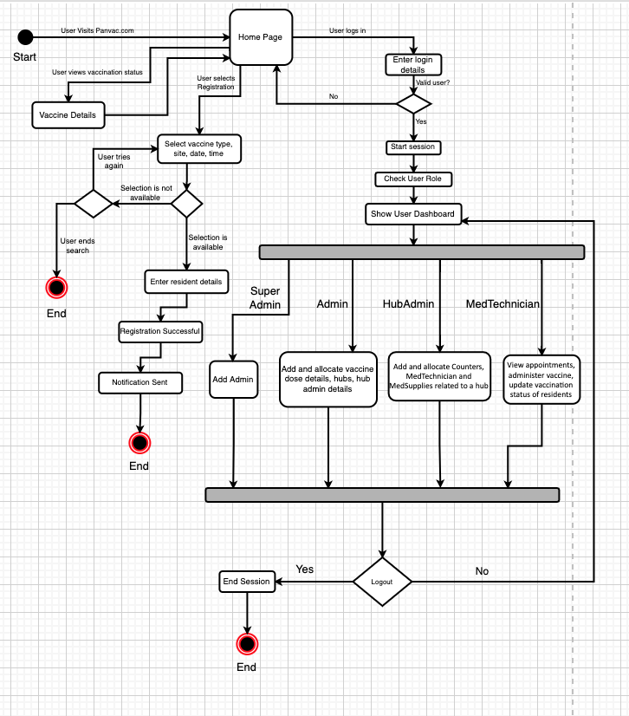

**Windows Navigation**

## 

## Login Page:

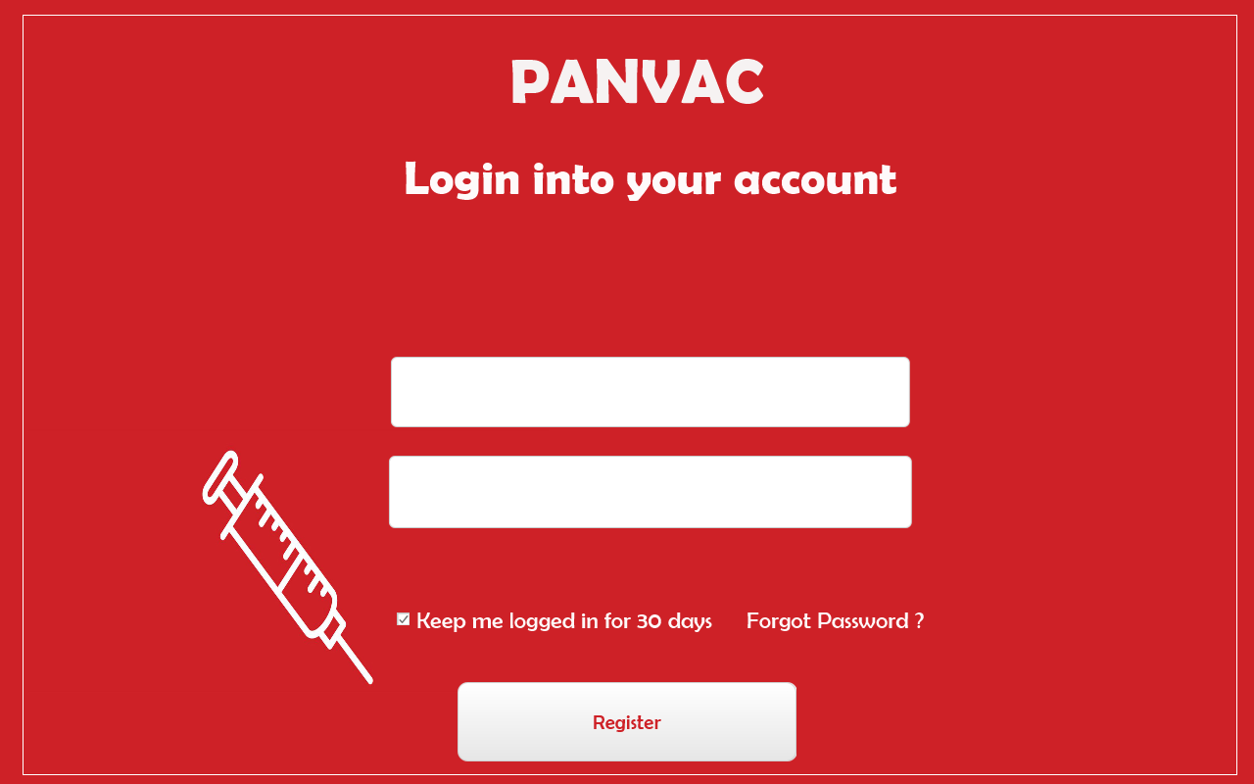

Registration Page:

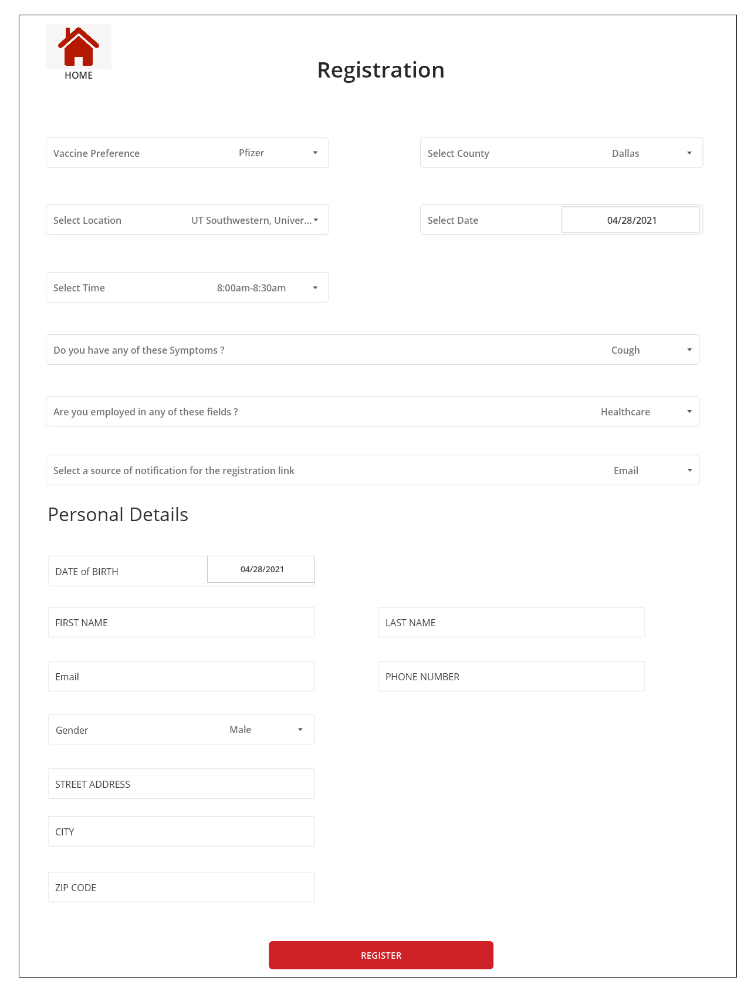

# 

# **Meeting Minutes**

Meeting 1:

|  |
| --- |
| Brief Description / Agenda |
| * Discuss and prepare the software design of the project. |

|  |  |  |  |
| --- | --- | --- | --- |
| Meeting Date | 04/18/2021 | Meeting Location | MS TEAMS |
| Meeting Time | 5:30 PM | Meeting Title | Group Project Milestone-4 |
| Attendees | Meenal Badki; Debshila Bhattacharya; Sreejaya Parameswaran, Mariya Khalid; Prabhavi Soni and Lakshit Rajput | | |

Meeting 2:

|  |
| --- |
| Brief Description / Agenda |
| * Discuss on the Test strategy and prepare Test cases applicable for the project. |

|  |  |  |  |
| --- | --- | --- | --- |
| Meeting Date | 04/24/2021 | Meeting Location | MS TEAMS |
| Meeting Time | 5:30 PM | Meeting Title | Group Project Milestone- 4 |
| Attendees | Meenal Badki; Debshila Bhattacharya; Sreejaya Parameswaran, Mariya Khalid; Prabhavi Soni and Lakshit Rajput | | |

Meeting 3:

|  |
| --- |
| Brief Description / Agenda |
| * Discussion on the user interface design approach and prepare navigation diagram as well. |

|  |  |  |  |
| --- | --- | --- | --- |
| Meeting Date | 04/28/2021 | Meeting Location | MS TEAMS |
| Meeting Time | 5:30 PM | Meeting Title | Group Project Milestone-4 |
| Attendees | Meenal Badki; Debshila Bhattacharya; Sreejaya Parameswaran, Mariya Khalid; Prabhavi Soni and Lakshit Rajput | | |